Ryno Single Wheel Motorcycle
By Jon Sun Li On MAY 15, 2014 · Business
http://teqy.co/ryno-single-wheel-motorcycle/?campaign_id=obr-3k

Ryno, an Oregon based company, has developed a single wheel motorcycle that will be a boon for urban transport due to its maneuverability within the confined spaces of any urban environment. The $1600 equipment may seem pricey, but considering that it is an electric motorcycle, the environmental and efficiency benefits cannot be gainsaid. This one-wheeled motorcycle can reach speeds of up to ten miles per hour and while this may seem a little too slow, the machine is designed with urban traffic in mind. This means that one is able to move around in places where other vehicles would not be able to and this can result in substantial savings in time considering the unbearable traffic conditions on modern roads. The motorcycle’s electric system control forward and back movements while turning is done like you would with a bicycle.

This One-Wheeled Electric Motorcycle Actually Feels … Safe
By Tim Moynihan 01.23.14 12:38 PM
http://www.wired.com/2014/01/ryno-electric-unicycle/

It takes a special kind of magic to make an electric one-wheeled motorcycle not terrifying to ride, and Ryno Motors has pulled it off. The microcycle, which has a single 25-inch motorcycle tire and reaches speeds up to 10 mph, uses a combination of gyroscope sensors and accelerometers to balance itself. That, combined with a strategic weight distribution and an intuitive acceleration and braking method, makes this motorized unicycle from the future actually feel … safe.

It’s a magnet for attention, too. Plenty of people at the WIRED New York office stopped by to check it out. Many of them wanted to ride it — in no small part because it looks and feels like something Syd Mead dreamed up. What inspired the vehicle is more cute than futuristic though.

“My daughter drew a sketch of a one-wheel motorcycle she saw in a video game and asked me to build it,” says Ryno CEO Chris Hoffmann. “She was 13 years old.”

What started out as a hobby seven years ago morphed into a business four and a half years later as the price of gyro sensors approached the $10 mark. The Portland, Ore.-based company will start shipping pre-orders of the Ryno this April.

Rather than use a hand-throttle like a motorcycle, you juice the Ryno simply by leaning forward as you would on a Segway. Leaning forward on the handlebars forces the sensor-balanced wheel to adjust its position for balance, which propels you forward. Braking is as easy as leaning back, but there’s also a hand brake if you’d rather slow down that way.

The Ryno is able to handle inclines up to a 20-percent grade, so it’s largely San Francisco-friendly. It also takes about six hours to charge up fully using a 12-volt DC charger. That gives it a range of about 10 miles or an hour per charge at top speed. Real-world usage — stopping, starting, and going more slowly — will probably yield quite a bit more than that. The removable, rechargeable batteries also power the Ryno’s LED headlights and light-up dash display.

It’s hard to describe what it feels like to ride the Ryno, but the main takeaway is it’s much easier and safer than it seems. The vehicle really does balance itself without a hitch, and getting the hang of leaning forward and backward to accelerate and decelerate takes only a few seconds.

Indeed, the self-balancing skills of the Ryno are impressive to the point of being miraculous. With the vehicle turned on and no one seated on it, Hoffmann pushed down as hard as he could on the handlebars while standing in front of it. It didn’t even budge on its single wheel as the gyro and motion sensors kicked in. Of course you can still tip it over from side to side fairly easily, but obviously your legs are there for stabilization.

A lot of what feels safe about riding the Ryno has to do with weight distribution. The entire vehicle weighs 160 pounds, with the wheel-and-motor portion accounting for most of that (140 pounds). That makes it feel extremely bottom-heavy and rooted to the ground. It also makes it easier to pick up. The lightweight seat and frame, which are made from a combination of CNC tube benders and 3D-printed parts, rocks back and forth on the wheelbase and absorbs shock.

How do you park a 160-pound unicycle? That’s another clever aspect of the Ryno’s design. The front of the vehicle’s frame comes together in a rubber-footed bar. Simply tipping the vehicle forward rests it on that bar like an oversized kickstand. Little foot pegs fold out from the sides of the tire; you can flip them down if you want to use them or lock them upward if you want to ride free-footed.

Like a Segway, the Ryno should be fine to use on sidewalks and bike lanes, but those regulations vary from state to state and city to city. In New York City, for example, a security guard asked us to stop riding the Ryno on an empty sidewalk. That’s probably because the vehicle looks a lot heavier and faster than it actually is.

To help with the Ryno’s adoption as a mainstream personal transportation vehicle, the company has enlisted an independent legal counsel to go from city to city to lobby for permission to ride it on walkways.

“Segway defined this space called personal mobility,” says Ryno’s Hoffmann. “These products are now considered OK anywhere a pedestrian can walk.”

In a lot of ways, the Ryno and the Segway are very similar vehicles — both have top speeds of less than 12 mph and a much smaller footprint than your average bicycle. That should help the Ryno’s quest for pedestrian-like treatment. According to Hoffmann, occupations such as park police or mall security guards are also interested in the Ryno: It’s cooler-looking, and it also offers benefits such as being able to take your hands off the steering column to nab running shoplifters.

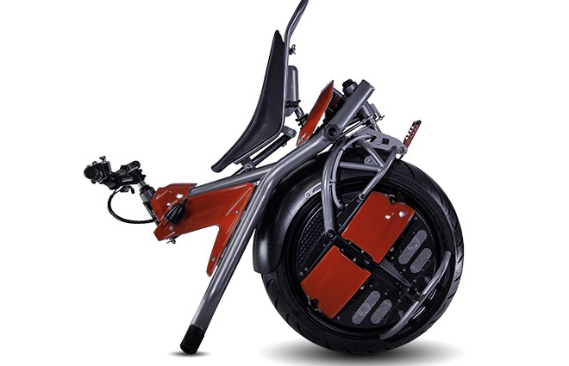
Image: Ryno Motors
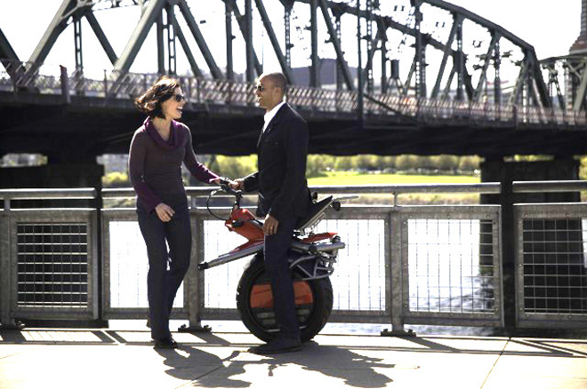
Image: Ryno Motors

