TECHNOLOGICAL INVENTIONS AND INNOVATIONS

http://www.pageorama.com/?p=magnetism
RIDDLES OF MAGNETISM

"I have been attracted by magnetism (as a scientific field) all the more because of the many riddles. It is full of wonders," Prof. Shogo Ueno said.

Ueno’s research has explored the relationship between magnetism and the human body for more than 40 years.

During 2010, this 67-year-old professor became the first Japanese to receive the d'Arsonval Award, the highest prize given by the international Bio-Electro-Magnetic Society (BEMS).

He frequently demonstrates the wonders of magnetism to people visiting his lab. For instance, he uses magnetic force to divide the water in a container, saying half-jokingly, “It's just like what Moses did in the Old Testament.”

Twenty years ago, Ueno devised a method to locally stimulate the brain by placing a figure-eight magnetic coil atop the head. The method, which has also been used to treat depression, has attracted much attention internationally.

“It's important for a researcher to possess an unfettered way of thinking. To do research properly, one should approach life from the point of view of, “I don't know anything,” said Ueno.
Source: Yomiuri News

It is impossible to fathom all the mysteries of magnetism, but how much more impossible it is to fathom the mysteries of God and His creation!

Above, beneath, around, behind, and in all of these mysteries is that which we scarcely dare speak of: the incredible mystery of God’s eternity, His omnipotence, His omnipresence, His omniscience, His righteousness and His love!

Such knowledge
is too wonderful for me,
too lofty
for me to attain
(Ps. 139:6, NIV).

A God whom we could comprehend, in whom we could find no unfathomable depth of mystery, would not be the God of the Bible!

http://www.pageorama.com/?p=water
CREATING DRINKING WATER OUT OF THIN AIR

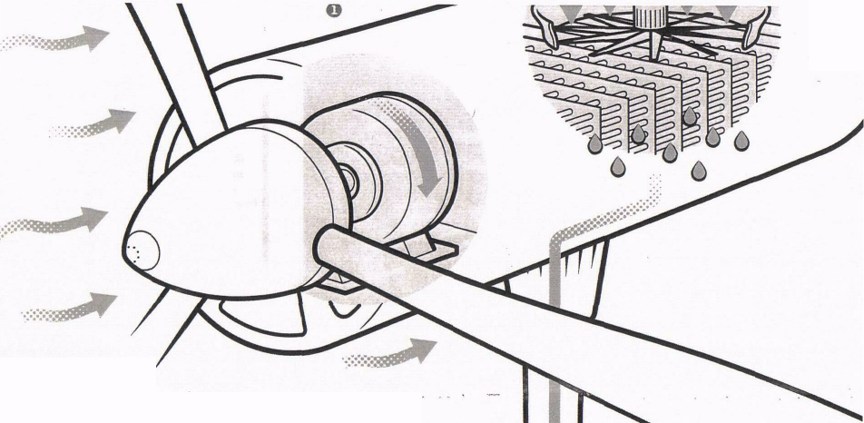
BY JACQUELINE DETWILER
HOW IT'S DONE

In addition to oppressive regimes and roving criminal bands, dystopian movies have long traded on our collective fear of water scarcity. And with close to a fifth of the world's population now living in areas without enough water, that particular specter becomes more of a reality every day. Fortunately, French inventor Marc Parent is on the job. After being inspired by a dripping air conditioner, he built a turbine that could capture potable water from wind, established a company, Hole Water, and began testing his prototypes amid some of the hottest, driest weather conditions on earth. "We wanted it to be a challenge," says Thibault Janin, a spokesman for Hole. "In French, the saying is “If the training is difficult, the war will be easy.'" Here's how they did it.

Removing water from the air requires electricity, which can be hard to come by in areas without an established power grid. The turbine takes care of that problem by harnessing the energy of winds in a shaft connected to a generator.
- Once electricity is available, a machine similar to a hair dryer pushes hot air across hundreds of chilled pieces of stainless steel alloy. The same principle that makes your mirror steam up during a hot shower causes water droplets to bead upon pieces of steel.
3. The collected water travels through a five-level treatment system, including a UV filter, to make it safe to drink. Each turbine can produce up to 1, 500 liters of drinking water every day, but each one will eventually provide between 20,000 and 25,000 liters a day, enough to support entire cities!

http://www.pageorama.com/?p=plastic-oil
YOUR HOME IS AN OIL FIELD
(Sent in by Kathy Yamada Source: The Internet)

Plastic, though convenient, causes many hazards. We’re running out of space to dump our non-biodegradable plastic waste, which is also polluting our oceans.

Akinori Ito, the CEO of Blest, a Japanese company, has a universal remedy. If plastic is just oil, why don’t we simply turn it back into what it was, he pondered. So Ito made a machine to do just that. His solution is safe, eco-friendly and efficient.

“If we burn the plastic, we generate toxins and a large amount of CO2. If we convert it into oil, we save CO2 and at the same time we should increase people’s awareness about the value in plastic garbage,” Ito said. Blest’s conversion technology is very safe because it uses a temperature controlling electric heater rather than a flame. The result is a crude gas that fuels generators or stoves and when refined, can even be pumped into a car, a boat or a motorbike.

Blest produces machines in a variety of sizes suitable for both industrial purposes and simple home use. There are already many machines in use across Japan at farms, fisheries, and small factories and some are being shipped overseas for the environmentally conscious and curious abroad.

One kilogram of plastic waste produces almost a liter of oil using about 1 kilowatt of electricity.

“Teaching at schools is the most important work that I do,” Ito reflects. He visits schools and shows children, teachers and parents how thrown away packaging and drinking straws from their lunches can be converted into oil.

“Plastic is everywhere in the world and everyone throws it away.” Ito said. “The home is the oil field of the future!”

The whole world depends on oil to function! How much more vital it is to those who belong to Christ, to have a ready supply of oil which is a type of the Holy Spirit! Without the Holy Spirit (oil in your lamp) you cannot enter the Kingdom of God! In the parable of the ten young virgins five were foolish and five were smart. Taking their lamps to meet the bridegroom, the silly virgins brought no extra oil and as they waited all night for the bridegroom their lamps went out. When they left to buy oil for their lamps, the bridegroom arrived. The smart ones were ready and went in to the wedding feast. Much later, the other virgins, the silly ones, showed up and knocked on the door, saying, “Master, we’re here. Let us in.” “Certainly not! I don’t know you,” the bridegroom answered. How tragic!
Those who were foolish took their lamps
and took no oil with them
(Matt. 25:3, NKJV).

http://www.pageorama.com/?p=purifying-bacteria

PURIFYING BACTERIA?

PURIFYING BACTERIA
Natto, considered a delicacy by most Japanese, is fermented soya beans that smell and taste awful!
Big Bio Co. in Fukuoka started to make porous concrete blocks with natto bacteria (Bacillus subtilis natto). Beneficial bacteria, the ‘subtilis natto group’, are encapsulated into blocks made of porous rocks which can then degrade and eliminate ammonia and organic substances that pollute water.
The blocks were placed in a fish tank and within a week the green algae was gone. One tank’s water was not changed for eight years and remained clear of all algae thanks to the beneficial bacteria. Indeed an interesting use of natto!
The beneficial bacterium flourishes in both fresh and salt water. Laying down EcoBio-Blocks in murky rivers or lakes results in cleaner water without causing any overload to the environment.
A string of orders for the EcoBio-Block are coming in from around the world. The company has developed a wide range of EcoBio-Block products such as the little EcoBio-Ring made to remove bad odors and slime typical to home aquariums.
Source: The Internet 2008-09-15
If Natto seems to miraculously purify water from pollution; how much more is God able to clean us from our inner contamination! Unless Jesus Christ washes us, we remain in the cesspool of our sins.
“When we were overwhelmed by sins,
you forgave our transgressions”
(Ps. 65:3, NIV).

