How My Twins Saved My Life by Kicking Loose A Tumour While Still In My Womb
By LUCY LAING - Last updated at 10:52am on 4th February 2008
http://www.dailymail.co.uk/pages/live/articles/health/healthmain.html?in_article_id=512113&in_page_id=1774
Like any thrilled mother to be, Michelle Stepney cherished the first kicks she could feel from her unborn babies. But her lively twin girls were doing more than simply making their presence felt. Each little kick was saving their mother's life.
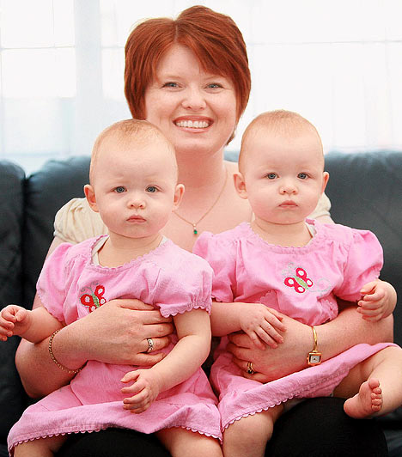
Mummy's little lifesavers: Michelle Stepney with twins Alice (left) and Harriet
Unknown to her, Mrs Stepney, 35, had developed cervical cancer. Her unborn twins' constant kicking in the womb actually managed to dislodge the tumour.
It was only when Mrs Stepney was taken to hospital with a suspected miscarriage that doctors realised she had cancer.
They told her the babies had saved her life. Without them, the cancer may not have been discovered until it was too late.
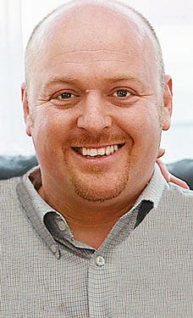
Then came another bombshell. In order to treat the cancer, she needed immediate chemotherapy and a hysterectomy, which would mean terminating the pregnancy.
Mrs Stepney refused. "I couldn't believe it when the doctors told me that the babies had dislodged the tumour," she said.
"I'd felt them kicking, but I didn't realise just how important their kicking would turn out to be.
"I owe my life to my girls, and that's why I could have never agreed with a termination."
Instead, she waited for her lifesaving treatment until they had been born.
Now the proud mother of year-old girls Alice and Harriet, Mrs Stepney has been given the all-clear.
She and her husband Scott, 36, a civil servant, were told they were expecting twins at a 14-week scan.
Support: Michelle says she couldn't have got through the ordeal without her husband Scott
The couple, who also have a five-year-old son, Jack, were thrilled. But three weeks later, Mrs Stepney was back at the hospital with a suspected miscarriage.
"I was just in shock when the doctors told me what it was. When they said that the babies had literally kicked my tumour out, I just couldn't believe it.
"If I hadn't been pregnant with the twins, the cancer may not have been discovered until it was too late.
"I knew I could have an operation straight away and it would cure me of the cancer, but that would mean getting rid of my babies and I couldn't do that.
"I had two lives inside me and I just couldn't give up on them - especially after they had saved me like this."
Doctors at the Royal Marsden Hospital in London agreed to give Mrs Stepney reduced chemotherapy in the hope of stopping the cancer spreading during the pregnancy.
"The doctors had tried this with women who were pregnant before, but they hadn't treated a woman with twins before. I knew it was our only hope," she said at her home in Cheam, South-West London.
She had chemotherapy every fortnight and was constantly scanned to monitor the babies' development.
"The doctors didn't know what the chemotherapy would do to the twins, and the first time I had it, I dreaded what it was doing to the girls. But they actually carried on growing well."
The twins were delivered by caesarean-section 33 weeks into the pregnancy, in December 2006. Alice weighed 3lb 11oz and Harriet 3lb 5oz.
"They were born without any hair as a result of the chemotherapy, but other than that, they were healthy.
"When I heard them both let out a cry, it was the best sound in the world."
Four weeks later Mrs Stepney had a hysterectomy to remove the tumour. Tests showed the cancer had not spread.
The twins have just celebrated their first birthday and are thriving. Mrs Stepney, an accountant, had a scan in December which showed she was still free from cancer.
She has been nominated for a Woman of Courage award by Cancer Research UK Race for Life and will be honoured at a ceremony in London on February 12.
"I've had wonderful support from my husband and I couldn't have got through it without him," she said. "I feel so lucky. And one day I will tell my daughters how they saved their mummy's life."

